Multiple Integration

The multiple integral is a generalization of the [definite integral](https://en.wikipedia.org/wiki/Definite_integral) to [functions](https://en.wikipedia.org/wiki/Function_(mathematics)) of more than one real [variable](https://en.wikipedia.org/wiki/Variable_(mathematics)), for example, *f*(*x*, *y*) or *f*(*x*, *y*, *z*). Integrals of a function of two variables over a region in R2 are called double integrals, and integrals of a function of three variables over a region of R3 are called triple integrals. Multiple Integral also known as iterated integrals because we integrate more than once.

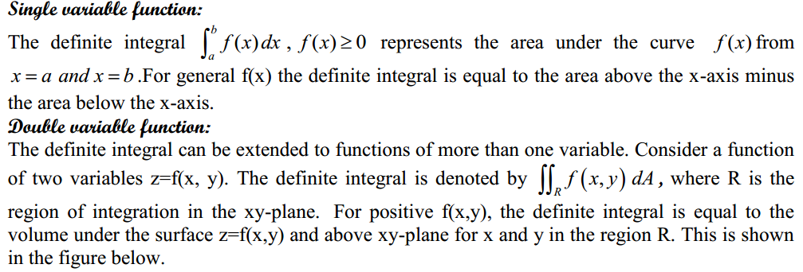

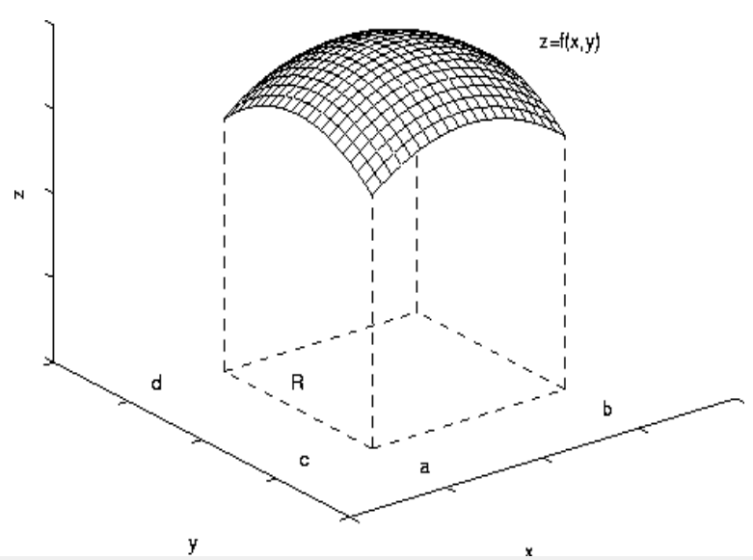

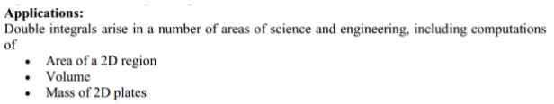

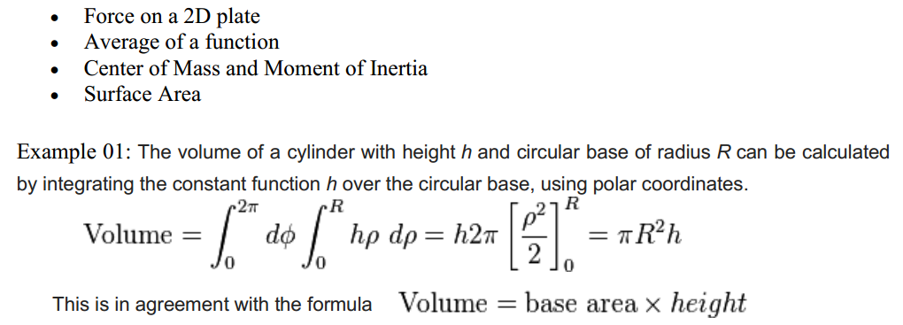

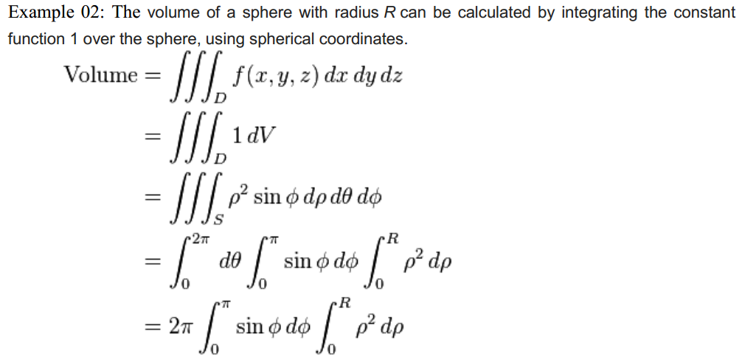

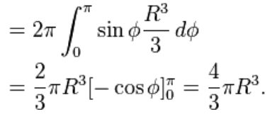

**Double Integration**

**Problem-01:** Evaluate 

**Solution:** Let, 

















  **(As desired)**

**Note:**  It turns out that the result of two iterated integrals are always equal when the order of integration is altered.

**Problem-02:** Evaluate 

**Solution:** Let,













 **(As desired)**

**Problem-03:** Evaluate 

**Solution:** Let, 























 **(As desired)**

**Problem-04:** Evaluate 

**Solution:** Let, 













 **(As desired)**

**Problem-05:** Evaluate 

**Solution:** Let, 























 **(As desired)**

**Problem-06**: Evaluate 

**Solution:** Let,

















 **(As desired)**

**Problem-07:** Evaluate 

**Solution:** Let, 

















 **(As desired)**

**H.W:**

**Problem-01:** Evaluate   **Ans:** 

**Problem-02:** Evaluate   **Ans:** 

**Problem-03:** Evaluate  **Ans:** 

**Problem-04:** Evaluate  **Ans:** 

**Problem-05:** Evaluate  **Ans:** 

**Problem-06:** Evaluate  **Ans:** 

**Problem-07:** Evaluate  **Ans:** 

**Problem-08:** Evaluate  **Ans:** 

**Problem-09:** Evaluate 

**Triple Integration**

**Problem-01:** Evaluate 

**Solution:** Let,























 **(As desired)**

**Problem-02:** Evaluate 

**Solution:** Let, 



















 **(As desired)**

**Problem-03:** Evaluate 

**Solution:** Let, 

























 **(As desired)**

**Problem-04:** Evaluate 

**Solution:** Let, 

























 **(As desired)**

**Problem-05:** Evaluate 

**Solution:** Let, 























 **(As desired)**

**H.W:**

**Problem-01:** Evaluate  **Ans:** 

**Problem-02:** Evaluate  **Ans:** 

**Problem-03:** Evaluate  **Ans:** 